My Nutrition Diary

Nutrient | Found in... (examples) | What it does/they do
carbohydrates | 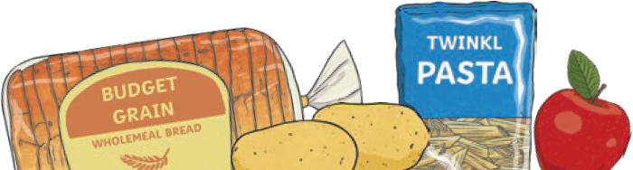 | provide energy
protein | 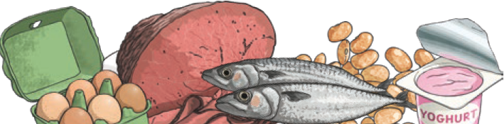 | helps growth and repair
fibre | 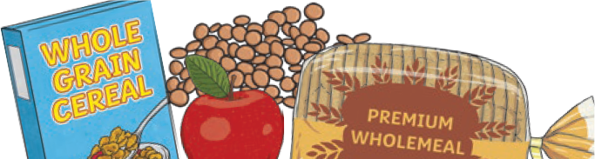 | helps you to digest the food that you have eaten
fats | 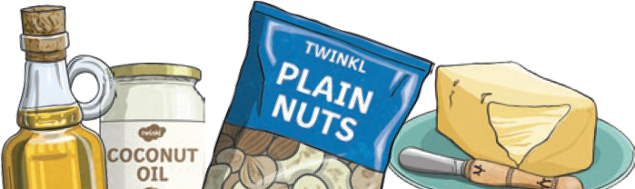 | provide energy
vitamins | 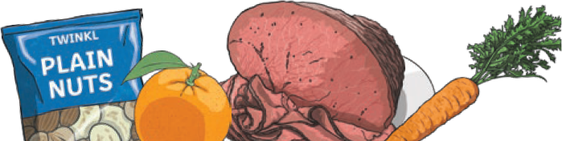 | keep you healthy
minerals | 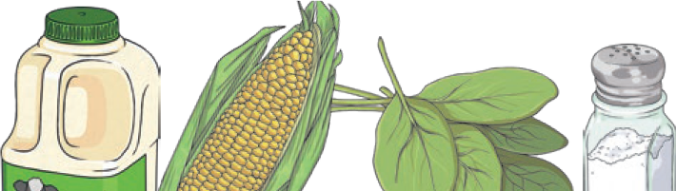 | keep you healthy
water | 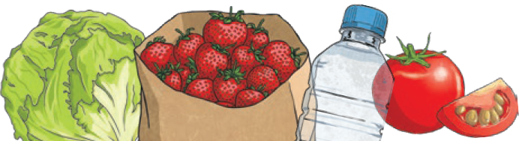 | moves nutrients around your body and helps to get rid of waste

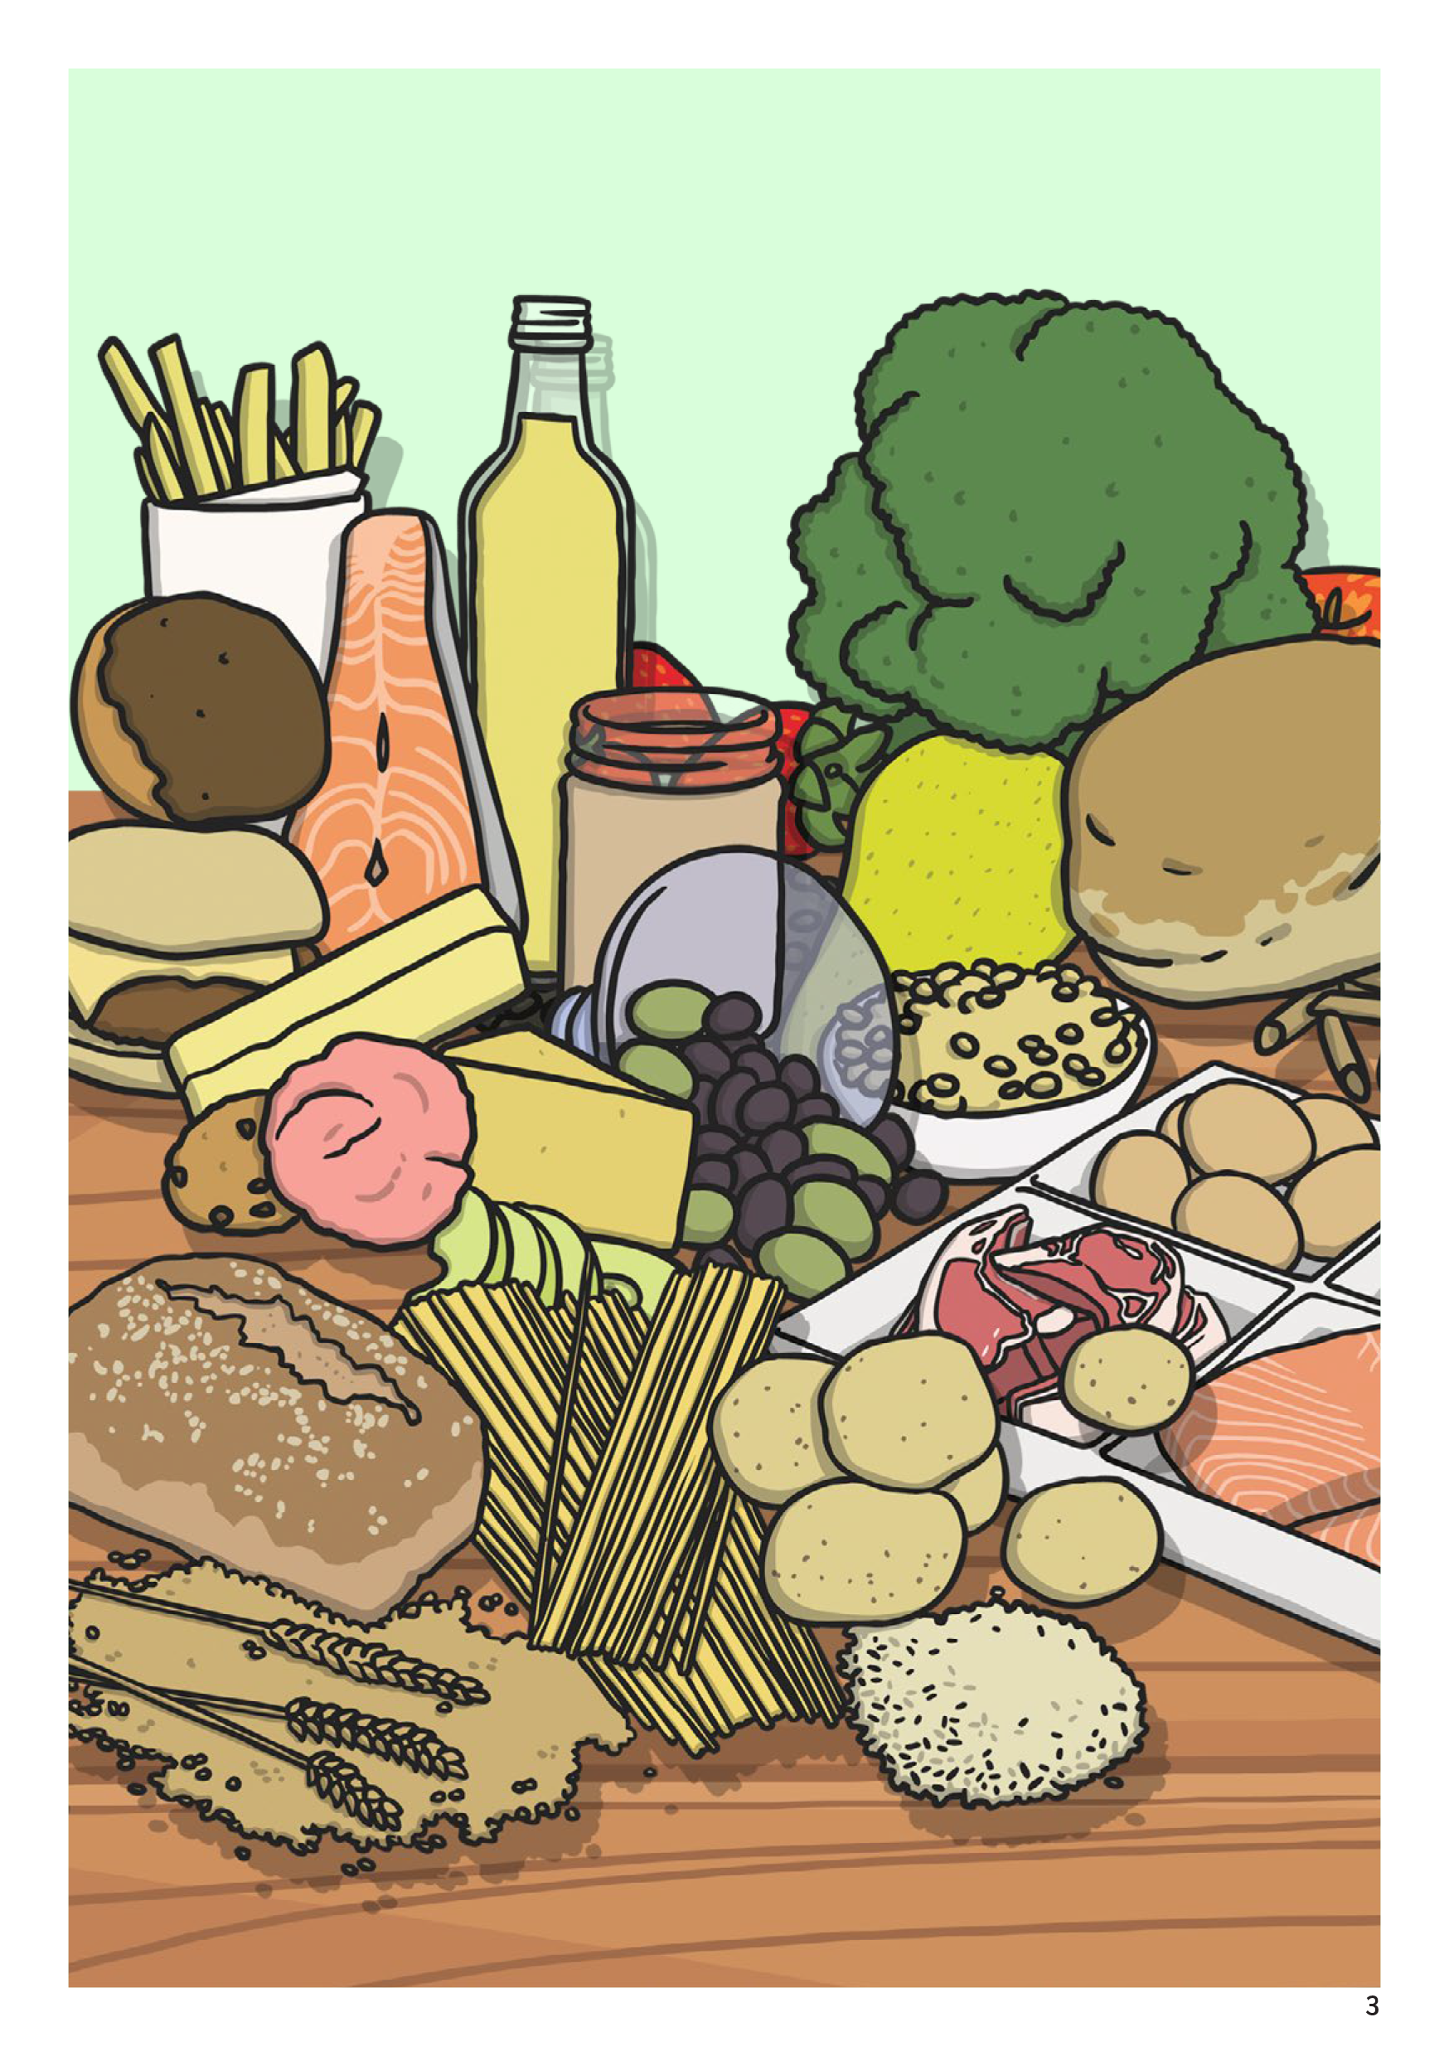

Monday
Draw or write what you ate and drank today
Breakfast | Lunch |  | Dinner | Snacks | Drinks
Write down which food gave you the following types of nutrients:
carbohydrates:
protein:
fats:
vitamins:
minerals:
fibre:
water:

Tuesday
Draw or write what you ate and drank today
Breakfast | Lunch |  | Dinner | Snacks | Drinks
Write down which food gave you the following types of nutrients:
carbohydrates:
protein:
fats:
vitamins:
minerals:
fibre:
water:

Wednesday
Draw or write what you ate and drank today
Breakfast | Lunch |  | Dinner | Snacks | Drinks
Write down which food gave you the following types of nutrients:
carbohydrates:
protein:
fats:
vitamins:
minerals:
fibre:
water:

Thursday
Draw or write what you ate and drank today
Breakfast | Lunch |  | Dinner | Snacks | Drinks
Write down which food gave you the following types of nutrients:
carbohydrates:
protein:
fats:
vitamins:
minerals:
fibre:
water:

Friday
Draw or write what you ate and drank today
Breakfast | Lunch |  | Dinner | Snacks | Drinks
Write down which food gave you the following types of nutrients:
carbohydrates:
protein:
fats:
vitamins:
minerals:
fibre:
water:

Saturday
Draw or write what you ate and drank today
Breakfast | Lunch |  | Dinner | Snacks | Drinks
Write down which food gave you the following types of nutrients:
carbohydrates:
protein:
fats:
vitamins:
minerals:
fibre:
water:

Sunday
Draw or write what you ate and drank today
Breakfast | Lunch |  | Dinner | Snacks | Drinks
Write down which food gave you the following types of nutrients:
carbohydrates:
protein:
fats:
vitamins:
minerals:
fibre:
water:

Notes
Space for any extra notes or drawings

