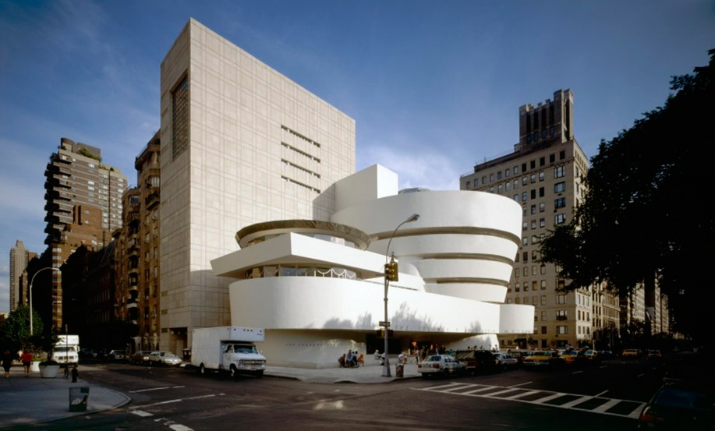**NEW YORK**

**ON MY TOUR I OBVIOUSLY SAW THE MUSEUM BUT I DID EXPLORE THE WHOLE CITY, I SAW THE TIME SQUARE WHICH WAS REALLY COOL BECAUSE THERE WAS SO MUCH PEOPLE AND IT WAS A VERY BUSY BUT FRIENDLY ENVIRONMENT WHICH I LOVED. I ALSO HAD THE FANTASTIC OPPURTUNITY TO WALK ON THE VERY FAMOUS ‘WALK OF FAME’.**

**MY FAVOURITE THING WAS MEETING TAYLOR SWIFT AND BON JOVI BECAUSE THEY ARE VERY FAMOUS AND HAVE GREAT MUSIC AND ALSO I CAN PLAY BON JOVI’S SONG ON THE GUITAR SO THAT IS ALSO ANOTHER REALLY COOL REASON OF MEETING HIM.**

**I WOULD DEFINITLEY RECOMMEND GOING BECAUSE EVERYONE IS REALLY NICE AND YOU GET THE OPPURTUNITY TO DO THINGS YOU NEVER THOUGHT YOU WOULD DO AND I NEVER THOUGHT I WOULD MEET ANYONE FAMOUS AND YOU ALSO THE SHOPS THERE ARE GREAT THEY HAVE EVERYTHING YOU COULD EVER IMAGINE THEY HAVE EVERYTHING YOU WISH THEY HAD HERE. THEY HAVE TOYS FOR ALL AGES, CLOTHES FOR ALL AGES AND REALLY NICE HOUSES.**

**I LEARNT THAT 18, 804,00 PEOPLE LIVE THERE AND ONLY 0.01% LEFT IN 2019 SO THAT WAS PRETTY COOL TO FIND OUT AND OVER 68 MILLION TOURISTS VISIT EACH YEAR INCLUDING ME.**

**SUCH GREAT ARTIFACTS AND INCREDIBLE DISPLAYS OF ART SUCH BEAUTIFUL THINGS IT REALLY IS JUST A PLACE TO EXPLORE**

**ONCE I WASTOLD TO GO SOMEWHERE AND DO SOME RESEARCH I KNEW I HAD TO GO SOMEWHERE ABSOLOUTELY EXTRAORDINARY, SO NEW YORK.**

**IT WAS INCRDIBLE AND I AM SO GLAD I WENT THERE AND I WOULD 100% GO AGAIN OF COURSE AND YOU DEFINITELY SHOULDGO THERE ASWELL. BUT DURING THIS EXPERIENCE THE HIGHLIGHT WOULD HAVE TO BE VISITING THE ‘SOLOMON R. GUGGENHEIM MUSEUM. IT WAS SO GREAT AND IT WAS FILLED WITH**