PREM SIDHU 5J 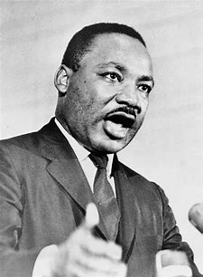
Martin Luther King
Martin Luther King Jr was born in Atlanta, Georgia on January 15TH 1929. He is a remarkable historical figure in American history. His life’s mission was to bring compassion, fairness and racial equality to all throughout the 1950’s and 1960’s.
He was a social activist and civil rights leader who fought against the longstanding segregation that plagued the South through peaceful marches and non-violent protests. He was inspired upon the teachings of Mahatma Gandhi and his church.
So your probably wondering what are civil rights? Each and every one is protected by civil rights that are granted by the U.S. government. This means that no matter the colour of their hair, skin, religion, age, disability or nationality, all people are equally controlled by the Constitution of the U.S. and cannot be discriminated against. Civil rights see to it that every individual is treated the same.
Martin Luther king achievements were:
- Montgomery Bus Boycott: Martin Luther King was not happy about people being divided on buses and the arrest of Rosa Parks after she refused to give up her seat on a public bus. Martin Luther King led the Montgomery Bus Boycott movement in 1955. It lasted over a year, resulting in the U.S. Supreme Court to rule that racial divide in public transport was not allowed.
- March on Washington: Martin Luther king organised the March in Washington in 1963 to bring awareness to the civil rights movement. Over 200,000 people attended the march to the Lincoln Memorial that day. This march helped the passing of the civil rights Act of 1964 that abolished discrimination based on race, colour, religion, sex or nationality. At this March, Marin Luther King gave a speech titled ‘I have a dream’, which went on to become one of the most famous, inspirational addresses in modern history that helped cement the idea of civil rights for all. You must watch this speech it is very powerful.
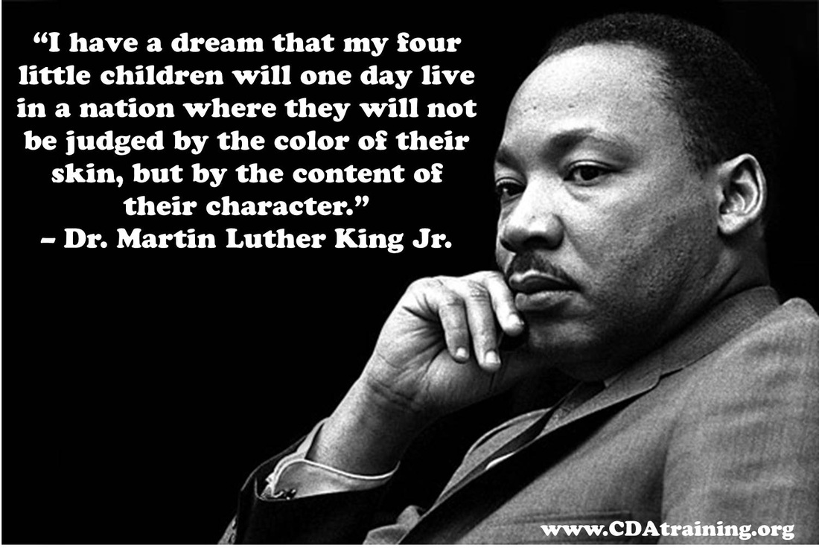

- Southern Christian Leadership Conference: Following the Montgomery Bus Boycott, Martin Luther King became president of the Southern Christian Leadership Conference to help lead the civil rights movement. He played a large role in helping the organisation focus their energy on peaceful protests and nonviolent marches to put an end to the divide across the country. The work he did for the Southern Christian Leadership Conference made him to be one of the most influential and prominent figures of the civil rights movement.
- Birmingham Campaign: In the early 1960’s Birmingham, Alabama, was one of the most divided cities in the U.S. This meant that certain people went to a different school, used a different bathroom, or drank out of a different water fountain based on the colour of their skin. The Birmingham Campaign was a series of protests led by Martin Luther King, aimed at ending Jim Crow Laws, which forced racial divide in public places. Sometimes the protests were not peaceful, Martin Luther king was sent to jail for a short period of time with other protestors. He was successful in his movement to break down divided barriers businesses, restaurants, and other public settings within Birmingham.
- Nobel Peace Prize: In 1964, Martin Luther King was awarded the Nobel Peace Prize for his efforts to usher in civil right for all. He was the youngest person to be honoured with this award.
Sadly Martin Luther King Jr was assassinated in 1968 in Tennessee, where he had given a speech the day before. He was standing on the balcony in his hotel when he was shot.
A statue built in his memory now stands in Washington D.C. and each year, the third Monday in January is celebrated as Martin Luther King Jr Day.

