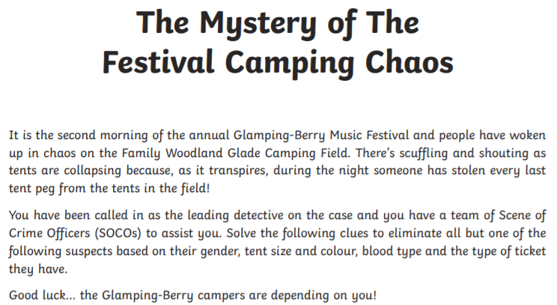
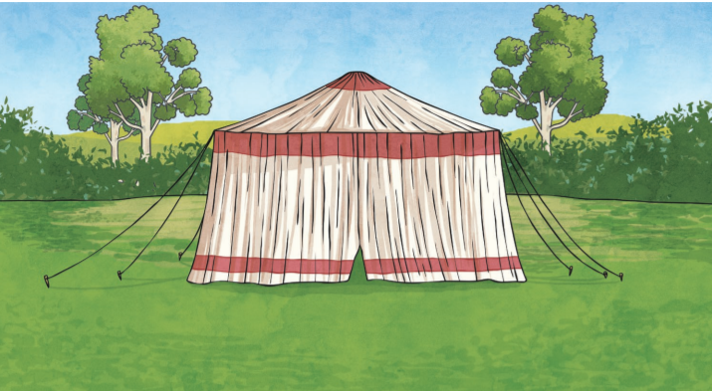
Detective name:

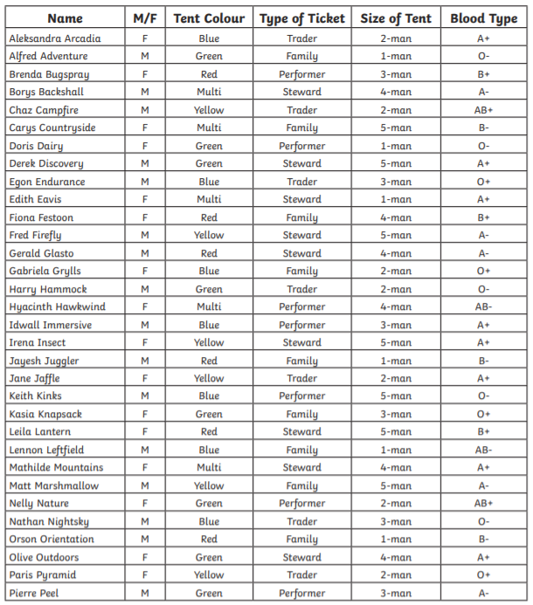

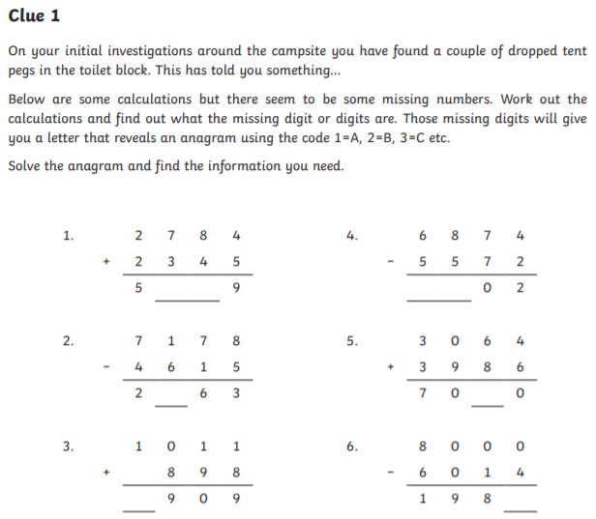
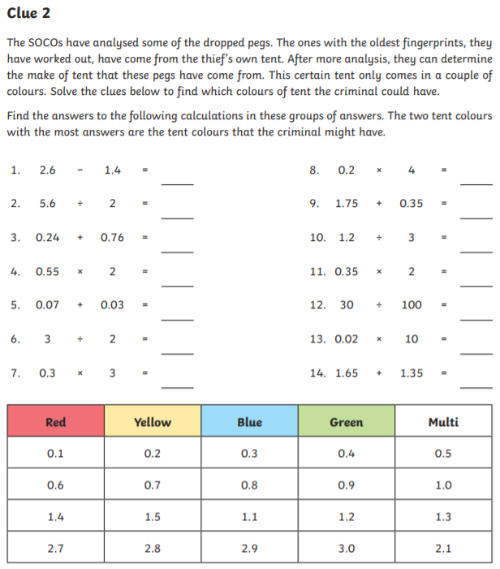
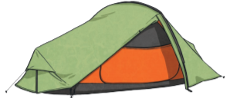

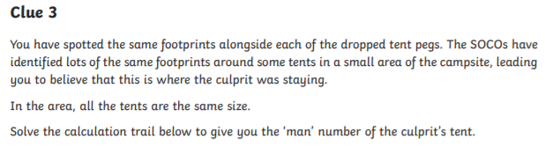
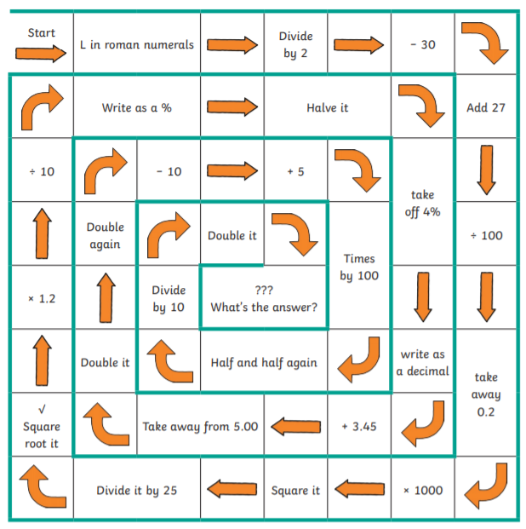

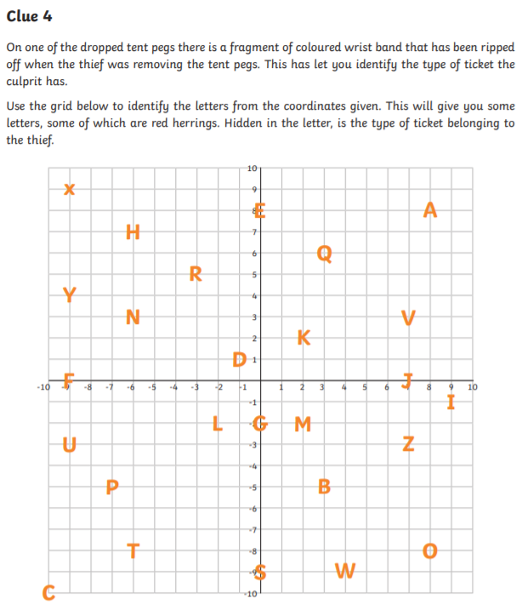
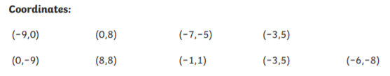

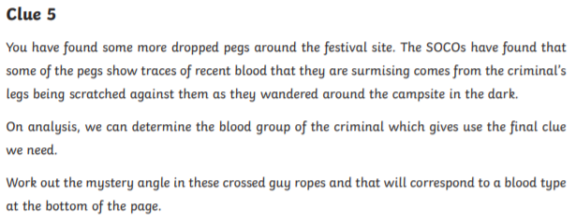
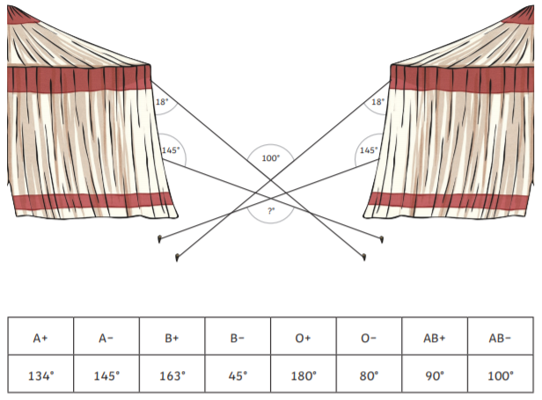
This one is tricky!
Tips: 3 angles in a triangle add up to 180°
Angles in a quadrilateral (4 sided shape) add up to 360°
Angles in a straight line add up to 180°
Opposite angles are equal on crossed lines.

Strategy: fill in any missing angles you can find until you have enough information to find the one we’re looking for.
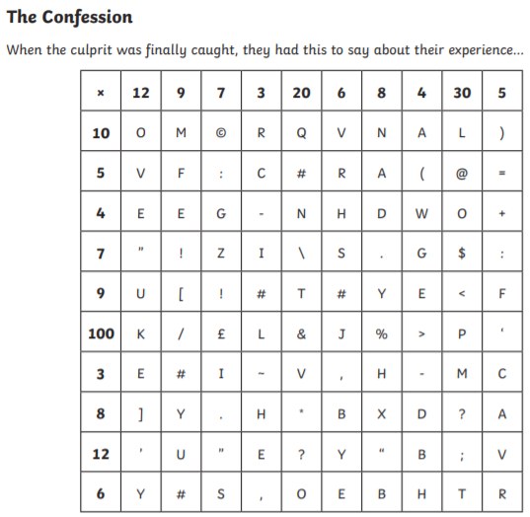
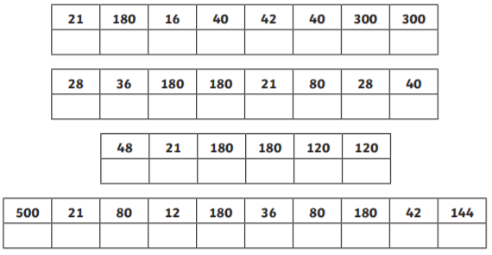

The Mystery of the Festival Camping Chaos- Answers
Clue | Answers
1 | 1.  2.  3. | 4.  5.  6.
2 | 1.  2.  3.  4.  5.  6.  7. | 8.  9.  10.  11.  12.  13.  14.
3
4 | _ _ _ _ _ _ _ _ _
5 | Missing angle = °
6 | 21 180 16 40 42 40 300 300  28 36 180 180 21 80 28 40  48 21 180 180 120 120  500 21 80 12 180 36 80 180 42 144
 | The culprit is…

