History Hackers: Victorian Venture
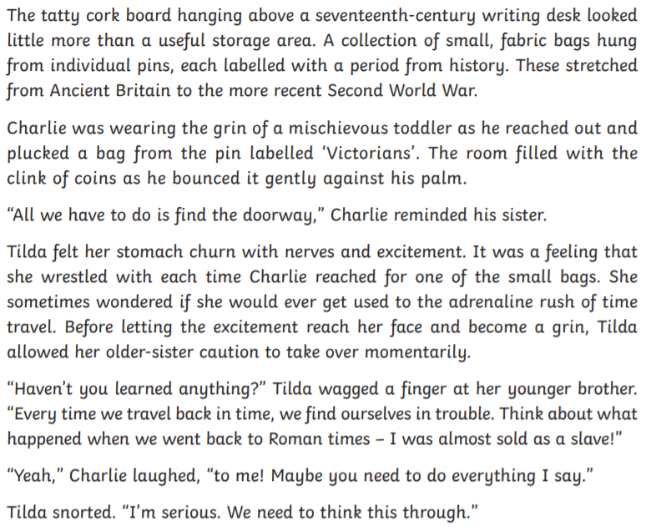
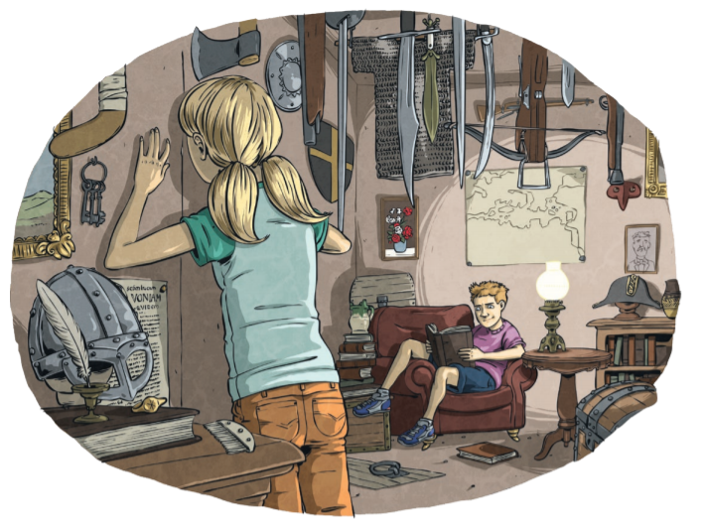

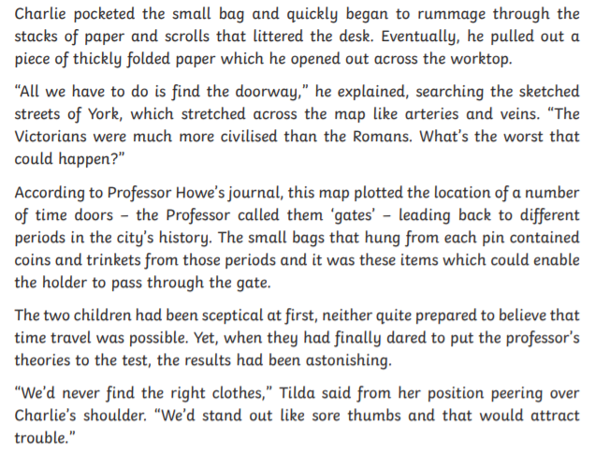
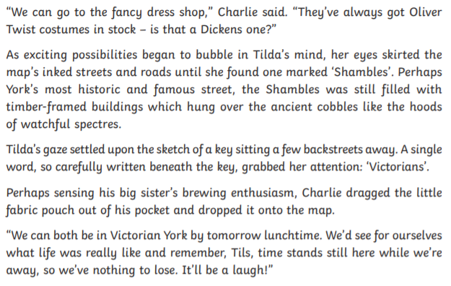

Questions
Q1. Number these events in the order they happen in the story. The first has been done for you:
1 | Tilda’s stomach churns with nerves and excitement.
 | Charlie rummages through the stacks of paper on the desk.
 | Charlie suggests that they go to the fancy dress shop.
 | Charlie opens the map out across the worktop.
 | Tilda says that they don’t have the right clothes.

Q2. Where did Charlie suggest they could get an Oliver Twist costume from?
Answer:

Q3. What was contained in the small, fabric bags?
Answer:

Q4. What problem had Tilda faced when going back to Roman times?
Answer:

Q5. What was Charlie’s impression of life for poor people in Victorian times?
Answer:

Q6. Look at paragraph 14. ‘…the Shambles was still filled with timber-framed buildings which hung over the ancient cobbles…’
What impression does this give of the street?
Answer:

Q7. Our topic for Autumn term is all about The Victorians and The Industrial Revolution. Below, make a list of Victorian/ Industrial Revolution questions you’d like us to answer through our learning.
1.
2.
3.
4.
5.
